Assessment in Computing

Informing Pupils of Targets:
- Following unit title pages in class Computing evidence files, pupils have an assessment objectives jigsaw which is shared with them at the beginning of each lesson.
- This ensures that pupils are accurately informed about the skills and knowledge they will be developing within every lesson and over time as part of a wider unit of work
- Pupils will self and peer-assess (where appropriate) against the assessment objectives on the jigsaw grid at the end of each lesson

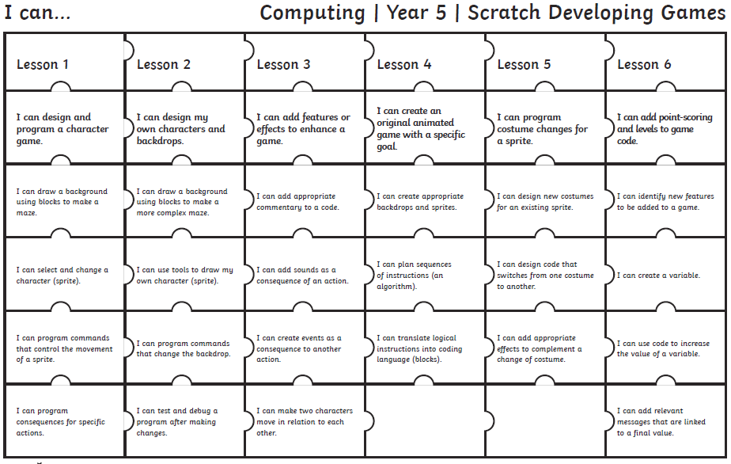

Ongoing Assessment:
- Class Teachers and HLTAs (where appropriate) use a range of Assessment for Learning strategies in order to formatively assess pupils’ achievements and progress within lessons.

Formal Assessment:
- Pupils’ achievements and progress are assessed formally by Class Teachers at the end of each unit of work (once per half term).
- An assessment spreadsheet is used to minimise unnecessary workload and enable data to be automatically calculated.

- Class Teachers can choose whether to update the spreadsheet at the end of each lesson or at the end of the unit of work
- The assessment spreadsheet breaks down specific objectives into ‘All’, ‘Most’ and ‘Some’ categories, progressing in difficulty

All | Indicates that a pupil is Working Towards ARE in the specified subject-specific objectives
All & Most | Indicates that a pupil is Working at ARE in the specified subject-specific objectives
All, Most & Some | Indicates that a pupil is Working at Greater Depth in the specified subject-specific objectives

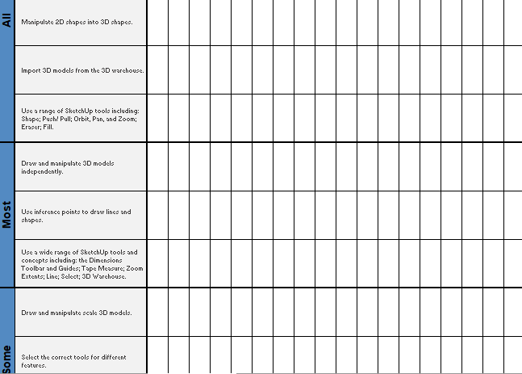

Reporting and Tracking:
- Class Teachers share completed assessment spreadsheets with the Subject Leader and Curriculum Lead (DHT) at the end of each unit
- The data submitted is analysed by Leaders in order to identify trends and areas for further development

Moderation:
- Non-Core assessment data is reviewed termly by Subject Leads, the Curriculum Lead and SLT and is subject to internal moderation.
- Class teachers discuss the attainment and progress of pupils in all non-core subjects at termly Pupil Progress meetings with members of SLT.

